Submitting ID

You need to submit your housing application ID through your Sheffield Property Shop (SPS) account. You can access the SPS website through all internet web browsers and even mobile devices.

This document guides you through the process of submitting your ID, which you will need to do when applying to join the housing register.

*Quick Tip
If you are unsure as to which documents you need to submit, guidance can be found in the ‘Information’ section of the SPS website. From here you can download the ‘Acceptable ID List’ and, also, the Landlord Reference template.

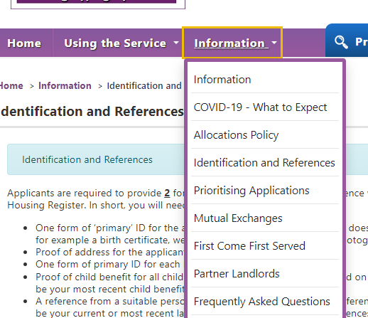

Submitting ID – Web Browser Version
When you log in to your SPS account, or complete a Social Housing Application, you will see your ‘My Account’ page:

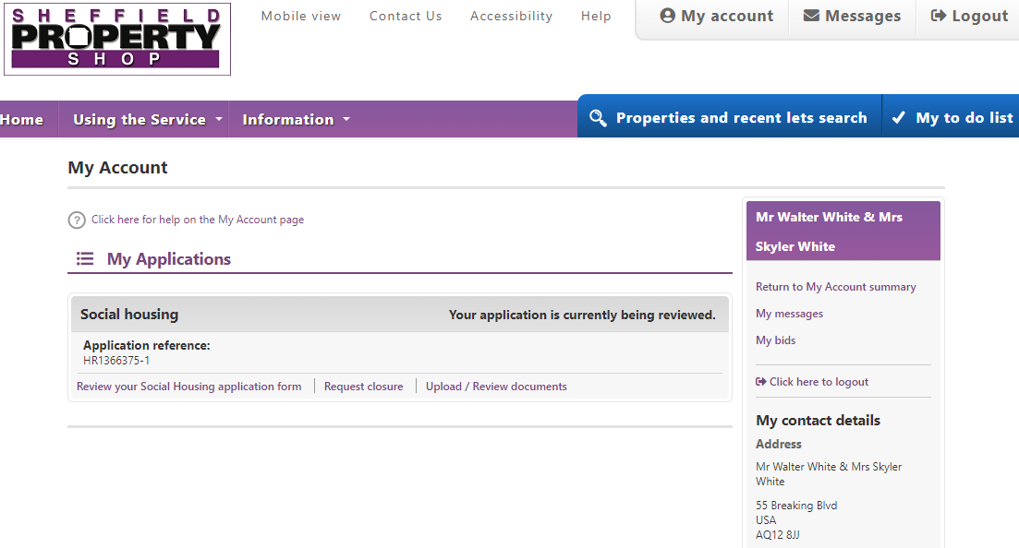

A link has been added to the ‘Social Housing’ section – Upload / Review documents:

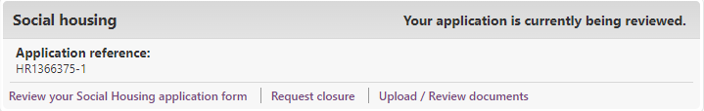
Clicking this link will bring up a page that has been created to allow you to submit the required ID as part of the application process.

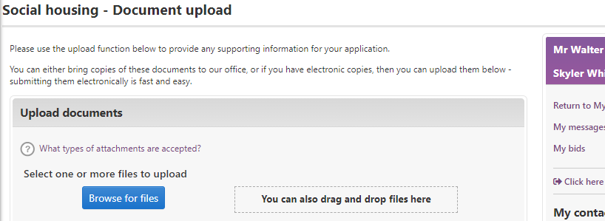

*Quick Tip
You can upload documents in two ways:

- Browse for files using the file search window - Best to do this if using a mobile device
- Drag and drop files from the ‘File Explorer’ window - Best to do this if using a PC/laptop

When adding your documents, using the dropdown boxes you must specify which documents you are uploading:
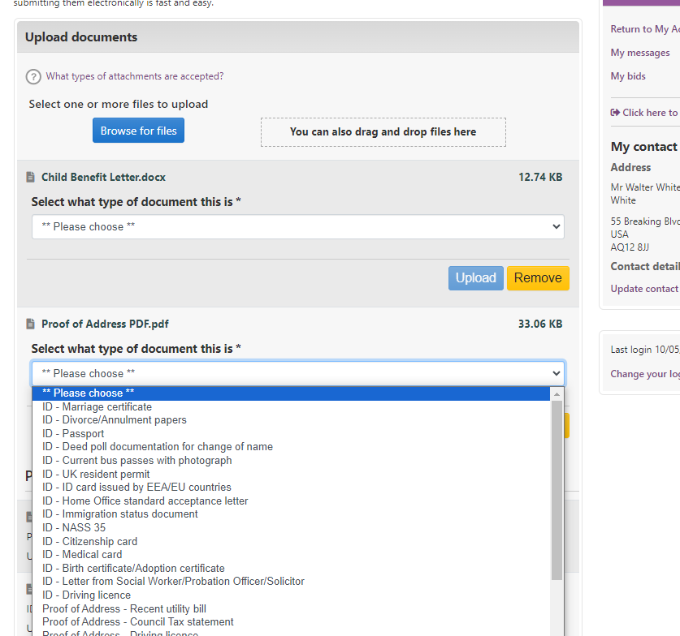

When you have selected the relevant ID description, click the ‘Upload’ button which will confirm the submission:

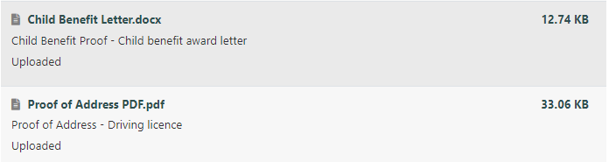
The documents will then show in our back-office system where an officer will be able to view and process them as part of the application validation process.

The documents will remain attached to your account until we delete them. We will delete the ID from the system if:

- The ID is incorrect or incomplete, and we need you to re-submit all of the documents – we will contact you to advise this.
- The ID is correct, and we no longer need to store the documents.

Submitting ID – Mobile Device Version

The process is similar if you are accessing the SPS website through a mobile device. The ‘My Account’ page still has the link to ‘Upload / Review documents’:

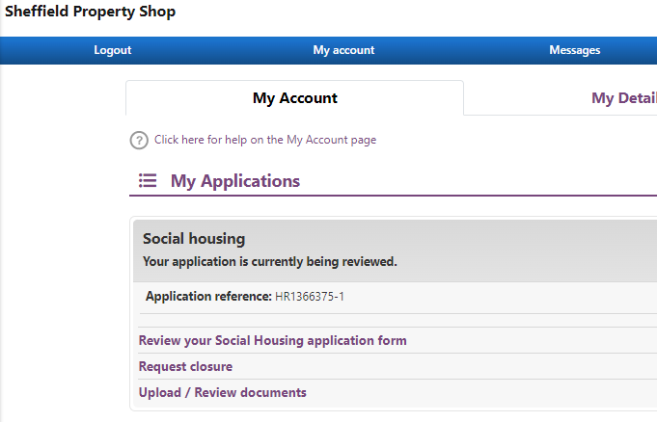

When you click on the link, the ‘Upload documents' page appears. It works in the same way as the desktop version:

